 Hale School

Semester 1, 2012

Question/Answer Booklet

MATHEMATICS
Circle your teacher’s initials

STL MAV

SPECIALIST 3CD

Section Two

(Calculator Assumed)

Your name

Time allowed for this section

Reading time before commencing work: 10 minutes
Working time for paper: 100 minutes

Material required/recommended for this section

To be provided by the supervisor
Question/answer booklet for Section Two.
Formula sheet.

To be provided by the candidate
Standard items: pens, pencils, pencil sharpener, highlighters, eraser, ruler.

Special items: drawing instruments, templates, notes on one unfolded sheet of A4 paper, and up to three calculators satisfying the conditions set by the Curriculum Council for this examination

Important note to candidates

No other items may be taken into the examination room. It is your responsibility to ensure that you do not have any unauthorised notes or other items of a non-personal nature in the examination room. If you have any unauthorised material with you, hand it to the supervisor before reading any further.

Structure of this examination

 | Number of questions | Working time (minutes) | Marks available
Section 1  Calculator Free | 8 | 50 | 50
This Section (Section 2)  Calculator Assumed | 12 | 100 | 100
Total marks |  |  | 150

Instructions to candidates

- The rules for the conduct of WACE external examinations are detailed in the booklet WACE Examinations Handbook. Sitting this examination implies that you agree to abide by these rules.

- Answer all the questions in the spaces provided.

- Spare answer pages are provided at the end of this booklet. If you need to use them, indicate in the original answer space where the answer is continued i.e. give the page number.

- Show all working clearly. Your working should be in sufficient detail to allow your answers to be checked readily and for marks to be awarded for reasoning. Incorrect answers given without supporting reasoning cannot be allocated any marks. Any question, or part question, worth more than 2 marks requires valid working or justification to receive full marks. If you repeat an answer to any question, ensure that you cancel the answer you do not wish to have marked.

It is recommended that you do not use pencil except in diagrams.

9. [8 marks]

From four numbers, three are chosen, averaged and the fourth one added. This can be done four ways, leaving out a different number each time. The four results are 17, 21, 23 and 29.
Let the four numbers be represented by a, b, c and d.

(a) Write down four equations involving the variables a, b, c and d.

[4]

(b) Use an inverse matrix method to determine the value of the four numbers.
Show clearly all the matrices involved.

[4]

10. [9 marks]

Consider the three vectors:

a = i – j + 2k, b = i + 2j + mk, and c = i + j – k , where m is real.

(a) Determine the exact value(s) of m for which | b | = 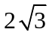.

[2]

(b) Find the value of m (to two decimal places) such that the acute angle between a and b
is 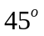.
[2]

(c) A is the point defined by the position vector a, B is the point defined by the position vector b and C is the point defined by the position vector c.

(i) Determine the vector equation, in terms of m, of the line which passes through the points A and B.

[3]

(ii) Determine the vector equation of the plane, in terms of m, which contains all three points A, B and C.

[2]

11. [9 marks]

The diagram below shows the graph of 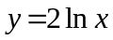, the point A (2, 4) and the tangent from A meeting the curve at B with coordinates (m, n).

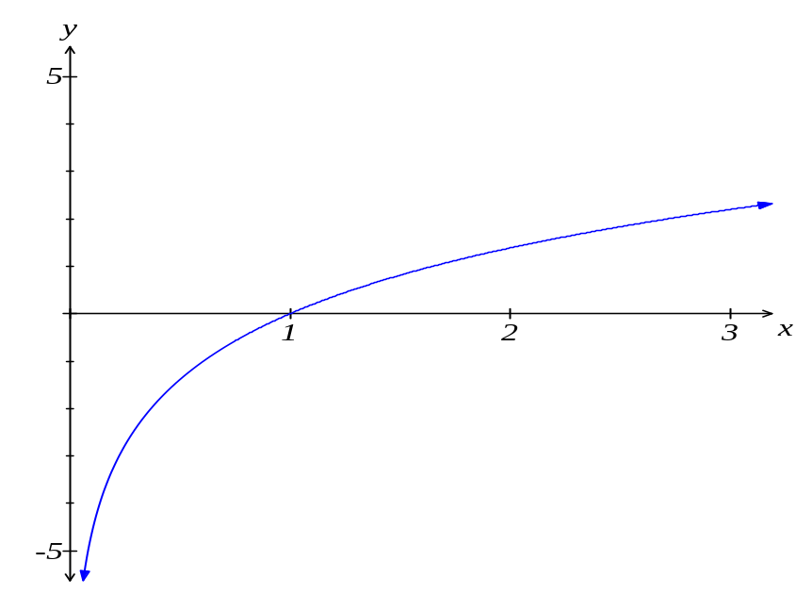
A (2, 4)
B (m, n)

(a) Determine an expression for the gradient of the curve at point B, in terms of m.

[2]

(b) Determine the gradient of the line joining A to B, in terms of m.

[1]

(c) Show that m satisfies the equation 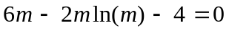.

[2]

(d) Hence, or otherwise, determine the equation of the tangent from A to the curve.

[4]

12. [12 marks]

The points A (-1, 0), B (2, 0) and C (-1, 3) form the vertices of a triangle.

(a) The three points A, B and C are transformed using the matrix M = 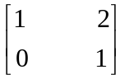 to produce the points A’, B’ and C’.

Describe the effect of the transformation matrix M.

[1]

(b) The points A’, B’ and C’ undergo a shear parallel to the vertical axis with a factor of 2 to produce the points A’’, B’’ and C’’.

As a result, the point C’ is vertically translated by k units to produce the point C’’.
What is the value of k ?

[4]

(c) On the set of axes below, draw triangles ABC and A”B”C”.

[2]
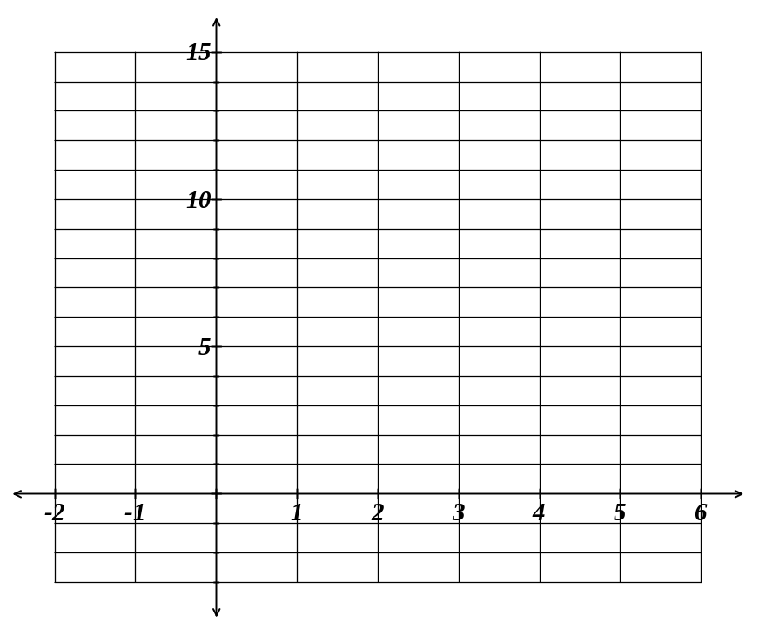

(d) What is the ratio of the area of triangle A’’B’’C’’ to the area of triangle ABC?

[2]

(e) What single transformation matrix will map A’’ back to A ?

[3]

13. [5 marks]

If a curve is defined by the rule 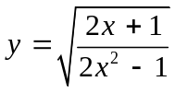, use logarithmic differentiation to determine the exact equation of the tangent to the curve at the point (1, ).
14. [4 marks]

If the argument of the complex number w is  and the argument of the complex number
z is ,

(a) show that 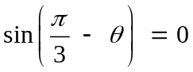
[2]

(b) sketch the set of all complex numbers z for which 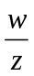 is real.
[2]

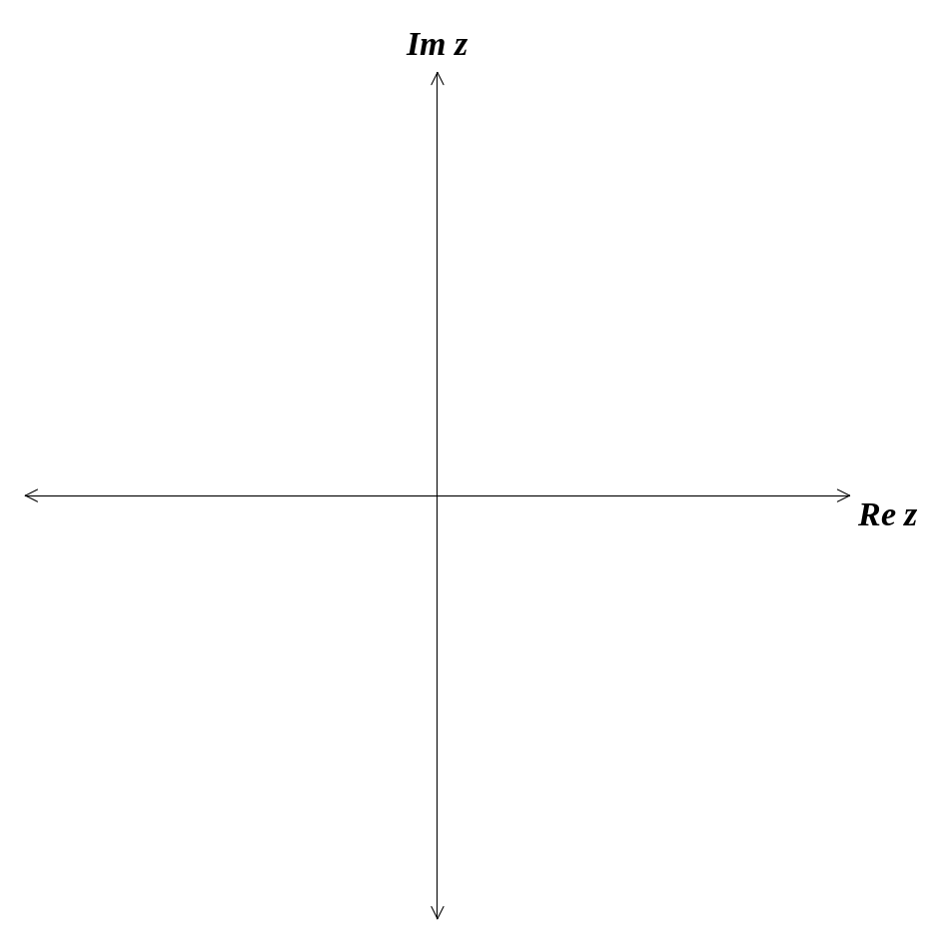

15. [13 marks]

Two radio-controlled model planes take off at the same time from two different positions and with constant velocities. Model A leaves from the point with position vector (–3i – 7j) metres and has velocity (5i – j + 2k) m/s; model B leaves from the point with position vector
(7i – j – 8k) metres and has velocity (3i – 4j + 6k) m/s.

(a) Determine the distance between the two planes after 2 seconds of flight.

[3]

(b) Show that the two planes do not collide with each other.

[3]

(c) Determine the shortest distance between the two model planes and the time at which this occurs.

[5]

(d) If the velocity of model B is (qi – 4j + 6k) m/s, determine the value of q such that the two planes do in fact collide.

[2]

16. [8 marks]

Person A and Person B are both on bikes which are separated by 350 metres. B is due east of A.
Person A starts riding north at a rate of 5 m/s and 7 minutes later Person B starts riding south at 3 m/s.
At what rate is the distance separating the two people changing 25 minutes after Person A starts riding?
17. [5 marks]

Consider the equation 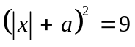.
Showing full reasoning, determine the solution(s) to the equation, in terms of a.
State the conditions necessary for the existence of each of the solutions provided.

18. [12 marks]

OAB is a triangle with 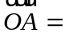a and 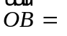b.
Points D, E, and F are the midpoints of each side of the triangle.
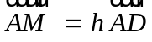 and 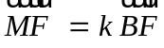

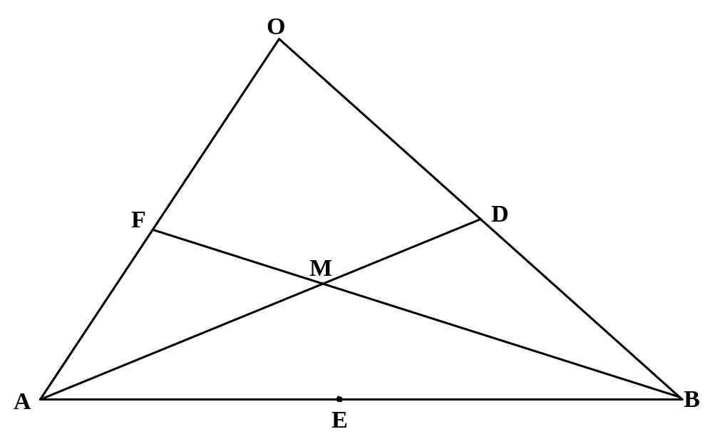

(a) Determine 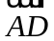 and 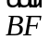 in terms of a and b.

[2]

(b) Determine 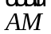 and 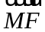 in terms of a, b, h and k.

[2]

(c) Hence determine the value of h and of k.

[5]

(d) Show that 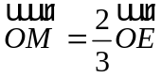.

[3]
19. [9 marks]

In the diagram below, Q(x₀, y₀) is a point on the unit circle 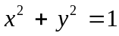 at an angle θ from the positive x-axis, where 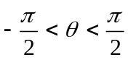. The line through N(0, 1) and Q intersects the line y = –1 at P. The points T(0, y₀) and S(0, –1) are on the y-axis.
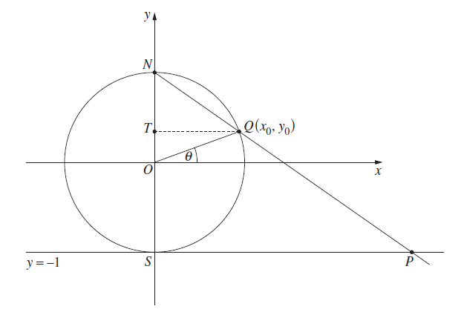

(a) Show that SP = 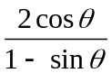.

[2]

(b) Show that 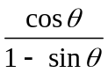 = 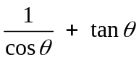.

[2]

(c) Show that 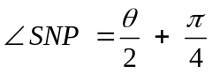.
[2]

(d) Hence, or otherwise, show that = tan 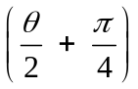.

[3]

20. [6 marks]

The line L has equation r = 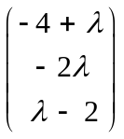.
The point A has position vector 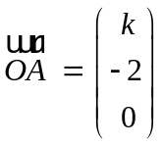, where k > 0.
If the shortest distance between the line L and the point A is 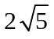 units, determine
the value of k. Show full reasoning.

SPARE PAGE FOR WORKING
SPARE PAGE FOR WORKING
SPARE PAGE FOR WORKING

